Matamata-Piako
Memorials

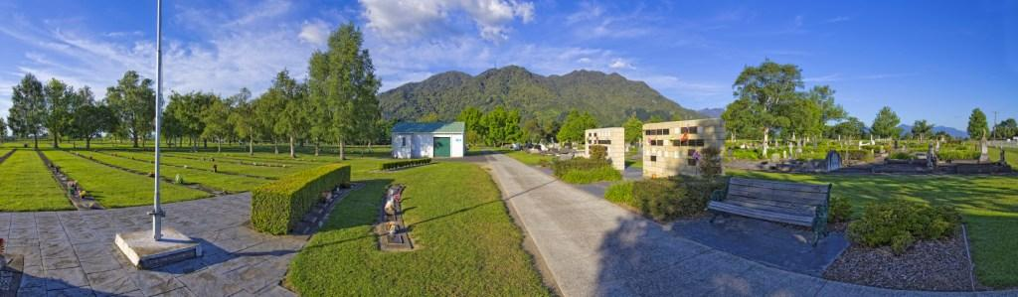

_____________________

All monuments/memorials must be approved by Council and a permit issued prior to installation.

Installation work in all cemeteries shall be carried out to the satisfaction of Council. Applications must be completed using the approved council form.

The family or representatives are responsible for providing, installing and maintaining the monument. Council may remove any installations that may fall into a state of disrepair.

If at any time the family or representatives wish to remove or replace the installation, they must obtain written permission from Council prior to removal.

No monuments other than approved headstones are to be installed within the cemetery.

No trees, shrubs or flowers shall be planted in any part of any cemetery without the consent of Council first being obtained.
Any memorial must comply with the requirements of Council – see the dimensions table over the page.
Dimensions Table

Type | Location | Dimensions
Plaques | Ashes Walls  – all cemeteries | Bronze only  370mm x 223mm
Plaques | Memorial Garden (Baby)  Piako Cemetery | Permanite only  150mm x 100mm
Plaques | Te Aroha Cemetery  – Ashes berms | Metal, Marble, Permanite or as approved upon application  370mm x 223mm
RSA Plaques | All cemeteries | Provided by RSA via Department of Internal Affairs
Lawn Cemetery Plaques  – full size plots | All Cemeteries  Te Aroha Lawn Cemetery Areas | Metal, Marble, Permanite or as approved upon application  455mm x 304mm
Recumbent desks  – for Plaques | All Cemeteries  Te Aroha Lawn Cemetery Areas | Height at rear – 75mm  Height at front – 25mm  Overall desk base must have at least 150mm clearance from the front of the plot (applies to Te Aroha only as it has double berms)

Monumental Masons complete the installation of plaques and headstones and other monuments within our Cemeteries. This is to ensure a consistent standard of installation and minimises the risk of poorly erected installations toppling, being subjected to vandalism and unauthorised removal.

Type | Location | Dimensions
Headstones – full plots, single berms | Matamata Cemetery | Max height incl plinth 1200mm. Front of installation must be 150mm from front and the back 150mm from the rear edge of berm.  Max depth of plinth 500mm (MM only). Max width of plinth/ headstone 1100mm
Headstones – full plots, single berms | Piako Cemetery  Te Aroha Cemetery  Block Kotuku | Max height inclplinth 1200mm.  Front of installation must be 150mm from front and the back 150mm from the rear edge of berm.  Max depth of plinth 400mm. Max width of plinth/headstone 1100mm
Headstones – full plots, double berms | Te Aroha Cemetery | Max height incl plinth 1200.  Front of installation must be 150mm from front edge of berm, rear of installation can be flush with centre line. Max depth of plinth 350mm.  Max width of plinth/ headstone 1000mm
Headstones – Ashes Plots | Piako Cemetery,  Matamata Cemetery  NB. All current ashes plots in Te Aroha are lawn (Plaques) cemetery plots only (see top of this section) | Max height incl plinth 600mm  Piako Cemetery max width 650mm and max depth 300mm deep  Matamata Cemetery max width 650mm x max depth 300mm
Headstones – Children Section | Piako Cemetery | Max height including plinth 600mm. Front of installation must be 150mm from front and the back 150mm from the rear edge of berm.  Max depth of plinth 300mm. Max width of plinth/ headstone 550mm

Frequently Asked Questions

What is the cost of a headstone?
The cost varies. You will need to contact a council approved monumental mason for a price.

Can we have a headstone that is placed across plots?
Yes, if you own the plots. If the monument crosses over a reserve (unoccupied) plot/s the reserve plot/s will not be able to be sold back to Council.

Can you purchase a plot, put a headstone on it and have it as a memorial only?
Yes, but you need to provide Council with the deceased details. An ‘Application to Inter’ form will also need to be completed (it will be noted that it is to be a memorial only).

How do I arrange for a memorial for an RSA plot?
Contact the local RSA branch:

Morrinsville 07 889 7014
Matamata 07 888 7190
Te Aroha 07 884 8124

Can I put a vase on the berm of the plot?
Yes, a hole for a vase is placed in the berm in most cemeteries. Council staff can confirm if this is available.

How do I get a vase for an ashes wall plot?
Vases must be bronze and can be purchased locally. Contact one of Council’s offices for more details.

What types of plots are available?
Please see the ‘Matamata-Piako Cemeteries’ brochure.

REG-3/5 – Issue 5

